1) Project Name
AI-Based Prediction of Student Dropout and Academic Success in Higher Education

2) Overview
This project aims to address one of the most pressing challenges in modern higher education: student dropout. By leveraging the power of Artificial Intelligence and machine learning, this project develops a predictive system that identifies students at risk of dropping out before it is too late. The core idea is to analyse a rich combination of demographic, academic, financial, and macroeconomic features collected at the time of student enrollment, and to use this data to train classification models capable of predicting whether a student will graduate, remain enrolled, or drop out of their programme.
The dataset used in this project originates from a higher education institution in Portugal and was made publicly available through the UCI Machine Learning Repository. It contains records of 4,424 students across 36 features, capturing everything from a student's age and marital status at enrollment to their semester-by-semester academic performance and their country's macroeconomic conditions at the time of study. The target variable divides students into three classes: Graduate, Enrolled, and Dropout. Importantly, the dataset is complete — containing no missing values — which makes it an ideal candidate for machine learning without requiring extensive imputation procedures.
The project follows a structured data science pipeline. Beginning with Exploratory Data Analysis (EDA) to uncover patterns and relationships within the data, it proceeds through data preprocessing — including handling class imbalance using techniques such as SMOTE — and culminates in the development and evaluation of multiple machine learning models including Logistic Regression, Random Forest, XGBoost, and Neural Networks. Model performance is assessed using metrics such as accuracy, F1-score, and AUC-ROC to ensure robust and reliable predictions.
By identifying at-risk students early — ideally at the end of the first academic semester — the system enables institutions to intervene proactively through targeted academic support, financial assistance, and personalised counselling. This not only improves individual student outcomes but also enhances institutional efficiency and contributes to the broader goal of equitable access to quality education worldwide. The project is directly aligned with United Nations Sustainable Development Goal 4 (SDG 4): Quality Education, and demonstrates how AI can serve as a practical tool for achieving global development targets.

3) Background
Student dropout from higher education institutions is a persistent and costly problem that affects students, institutions, and societies across the globe. According to the OECD, completion rates in higher education remain a significant concern, with many countries reporting that a substantial proportion of enrolled students never reach graduation. The consequences of dropping out extend far beyond the individual: incomplete degrees limit career opportunities and lifetime earnings, institutions lose revenue and reputation, and societies miss out on the skilled workforce they need to sustain economic growth and social development.
Traditional approaches to addressing dropout have largely been reactive. Academic advisors intervene only after a student has already begun to struggle — when grades have fallen, attendance has declined, or financial difficulties have become critical. By this stage, it is often too late for meaningful intervention. The challenge, therefore, is not merely to understand why students drop out after the fact, but to predict who is at risk before the situation becomes irreversible.
In recent years, the rapid growth of educational data — combined with advances in machine learning and artificial intelligence — has opened up new possibilities for early warning systems in education. Institutions now collect vast amounts of data on their students, from enrollment records and academic transcripts to financial aid status and demographic information. Machine learning models can be trained on this data to detect subtle patterns that human advisors would be unable to identify manually, enabling timely, data-driven interventions at scale.
This project is directly aligned with Sustainable Development Goal 4 (SDG 4): Quality Education, which calls for inclusive and equitable quality education and promotes lifelong learning opportunities for all. Specifically, it contributes to Target 4.3, which aims to ensure equal access to affordable technical, vocational, and higher education, and Target 4.5, which seeks to eliminate gender disparities and ensure equal access for vulnerable populations. The EDA conducted in this project reveals stark disparities in dropout rates across gender, financial status, and age group — findings that have direct implications for policy and institutional practice.
The dataset used in this project was compiled from a Portuguese higher education institution and covers students admitted between 2008 and 2019 — a period that spans one of the worst economic crises in European history, including the 2008–2009 global financial crisis and the subsequent European sovereign debt crisis. This temporal variation introduces macroeconomic features such as GDP growth rate, unemployment rate, and inflation rate into the dataset, allowing investigation of how broader economic conditions interact with individual student characteristics to influence academic outcomes.

Exploratory analysis of the dataset reveals several striking findings. Academic performance during the first two semesters is by far the strongest predictor of dropout, with correlations of -0.572 and -0.481 between semester grades and dropout status. Students who drop out pass an average of only 2.55 curricular units in their first semester, compared to 6.23 for graduates — a gap that is starkly visible in the data. Financial factors also play a critical role: students who are behind on tuition payments have a dropout rate of over 60%, while scholarship holders drop out at a rate of just 12.2%. Gender and age are further significant factors — male students drop out at nearly double the rate of female students (45.1% vs 25.1%), and older students carry substantially higher risk. Counterintuitively, macroeconomic indicators such as GDP growth rate show only a weak correlation with dropout, suggesting that individual-level academic and financial circumstances are far more decisive than the broader economic environment.
These findings motivate a machine learning approach that prioritises academic performance and financial status features while incorporating the full breadth of available data. The ultimate goal is a robust, interpretable predictive model that can serve as the backbone of an institutional early warning system — one that flags at-risk students at the end of their first semester and triggers tailored support interventions before it is too late.

4) Key Objectives / Business Objectives

4.1) Research Questions:
- What demographic and academic features available at the time of enrollment are most predictive of student dropout in higher education?
- At which stage of the student journey — enrollment, first semester, or second semester — can an AI model most reliably identify students at risk of dropping out
- What kind of machine learning algorithm provides the best trade-off between predictive accuracy and interpretability for a student dropout early warning system?
- How do financial factors such as tuition fee payment status, scholarship holding, and debt compare to academic performance features in their ability to predict dropout?
- Does incorporating macroeconomic indicators such as GDP growth rate and unemployment rate meaningfully improve model performance, or are individual-level features sufficient
- How does the model perform across different student subgroups — for example, by gender, age at enrollment, or course — and are there systematic disparities in prediction quality?
- Can the predictive model generalise beyond the Portuguese higher education context, and what adaptations would be required for deployment in other institutional or national settings?

4.2) Key Steps:
- Design and implement a full exploratory data analysis pipeline to uncover patterns in demographic, academic, financial, and macroeconomic features and their relationship to student dropout.
- Develop and apply a comprehensive data preprocessing workflow, including feature scaling, label encoding, and class imbalance correction using SMOTE, to prepare the dataset for machine learning.
- Train and compare multiple classification models — including Logistic Regression, Random Forest, XGBoost, and a Multi-Layer Perceptron Neural Network — on the preprocessed dataset.
- Optimise each model's hyperparameters using cross-validated grid search to ensure fair and robust performance comparisons across algorithms.
- Evaluate all models using a consistent set of metrics — accuracy, precision, recall, F1-score, and AUC-ROC — with particular attention to performance on the minority Dropout class.
- Generate and interpret feature importance rankings from the best-performing model to understand which factors most strongly drive dropout risk.
- Assess whether macroeconomic features contribute meaningful predictive power beyond demographic and academic features, using ablation experiments.
- Prototype a conceptual early warning system interface that illustrates how the final model could be deployed within an institutional student management system.
- Publish a full project report documenting findings, model performance, limitations, and recommendations for real-world deployment.

5) Methods and Workflow
5.1) Dataset:
The dataset used in this project is the "Predict Students' Dropout and Academic Success" dataset, published by Realinho et al. (2022) and made publicly available through the UCI Machine Learning Repository. It contains records of 4,424 students enrolled across multiple undergraduate programmes at a higher education institution in Portugal between 2008 and 2019. Each record includes 36 features spanning four categories — demographic, academic, socioeconomic, and macroeconomic — along with a target variable classifying each student as Graduate, Enrolled, or Dropout. The dataset contains no missing values. The target variable is moderately imbalanced, with graduates comprising 49.9% of records, dropouts 32.1%, and currently enrolled students 17.9%.

The 36 features can be grouped as follows:
- Demographic features: age at enrollment, gender, marital status, nationality, international student status, displaced student status, educational special needs.
- Academic features: admission grade, previous qualification and grade, application mode and order, course code, daytime/evening attendance, curricular units enrolled/evaluated/approved/graded for both the 1st and 2nd semesters, curricular units without evaluations.
- Socioeconomic features: mother's qualification, father's qualification, mother's occupation, father's occupation, scholarship holder status, tuition fees up to date, debtor status.
- Macroeconomic features: GDP growth rate, unemployment rate, inflation rate at the time of enrollment.

5.2) Data Cleaning and Preprocessing:
Although the dataset contains no missing values, several preprocessing steps are required before model training. First, the target variable is label-encoded, mapping the three outcome classes — Dropout, Enrolled, and Graduate — to integer values for use in multi-class classification algorithms. Second, all 36 numerical features are standardised using StandardScaler, which centres each feature to a mean of zero and scales it to unit variance. This step is essential for distance-based and gradient-based algorithms such as Logistic Regression and Neural Networks, which are sensitive to differences in feature scale. Third, the class imbalance in the target variable is addressed using the Synthetic Minority Over-sampling Technique (SMOTE), which generates synthetic examples of underrepresented classes to balance the training distribution and prevent models from being biased towards the majority Graduate class. Fourth, the processed dataset is split into training (80%) and test (20%) subsets using stratified sampling to ensure that the class distribution is preserved in both splits. Fifth, a feature selection step is applied based on the correlation analysis and mutual information scores computed during EDA, with the goal of reducing dimensionality and mitigating the risk of overfitting.

5.3) Model Development:
Four classification algorithms are trained and evaluated in this project, chosen to span a range of model complexity and interpretability. Logistic Regression serves as the interpretable baseline, providing a linear decision boundary and easily readable feature coefficients. Random Forest, an ensemble of decision trees trained using bagging, provides strong non-linear performance with good generalisation and built-in feature importance scores. XGBoost, a gradient-boosted tree ensemble, represents the current state of the art for tabular classification tasks and is expected to yield the highest raw performance. Finally, a Multi-Layer Perceptron Neural Network with two hidden layers is included to explore whether deep representations of the feature space offer additional predictive power over tree-based methods. All models are trained on the SMOTE-balanced training set and evaluated on the held-out test set, using five-fold cross-validation to ensure that reported performance estimates are robust.

5.4) Evaluation:
Model performance is assessed using five metrics. Accuracy measures the overall proportion of correctly classified students. Precision and Recall are computed per class and reported as macro-averages. The F1-score is used as the primary ranking metric given the class imbalance. The Area Under the ROC Curve (AUC-ROC) is reported for each class in a one-versus-rest configuration. Confusion matrices are also generated for all models to assess misclassification patterns — in particular, how often the model fails to identify students who will drop out, which represents the highest-cost error type from an institutional standpoint.

6) Exploratory Data Analysis (EDA)
Exploratory Data Analysis was conducted across all 36 features and the target variable to uncover distributions, patterns, correlations, and anomalies in the data. The following sections summarise the key findings, with reference to the accompanying visualisations produced during analysis.

6.1) Target Variable Distribution
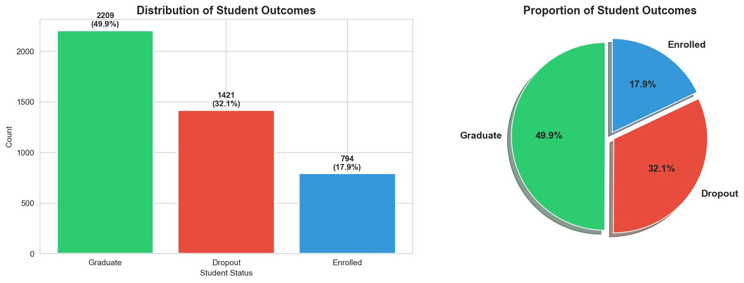
The target variable reveals a moderately imbalanced dataset. Of the 4,424 student records, 2,209 (49.9%) students graduated, 1,421 (32.1%) dropped out, and 794 (17.9%) remain enrolled. The dominance of the Graduate class has direct implications for model training: without correction, classifiers will be incentivised to predict graduation by default, suppressing their ability to detect the dropout cases that are of greatest practical interest. This imbalance is addressed in preprocessing using SMOTE.

6.2) Correlation Analysis
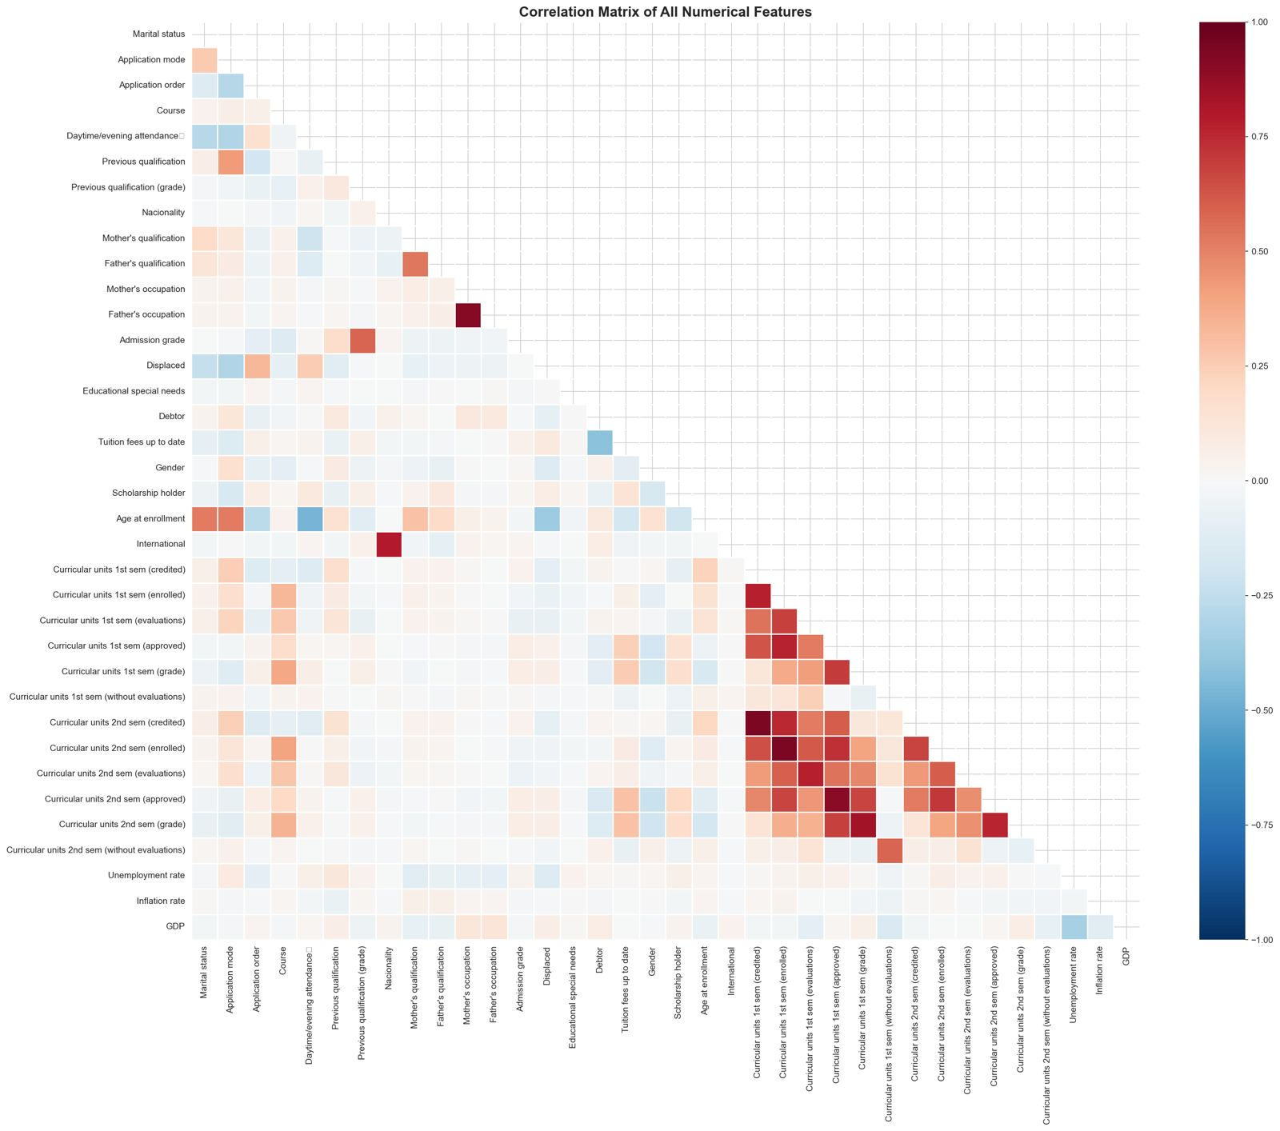
A pairwise correlation matrix was computed across all numerical features. Several strong relationships were identified: the number of curricular units approved in the 1st and 2nd semesters is highly correlated with the corresponding semester grades (r = 0.69), confirming that students who pass more units tend to achieve higher grades. The 1st and 2nd semester performance metrics are also strongly correlated with each other, suggesting that early academic difficulties are persistent across semesters. Macroeconomic variables — GDP, unemployment rate, and inflation rate — show weak correlations with most other features, indicating that they contribute relatively independent signal.

6.3) Academic Performance Analysis
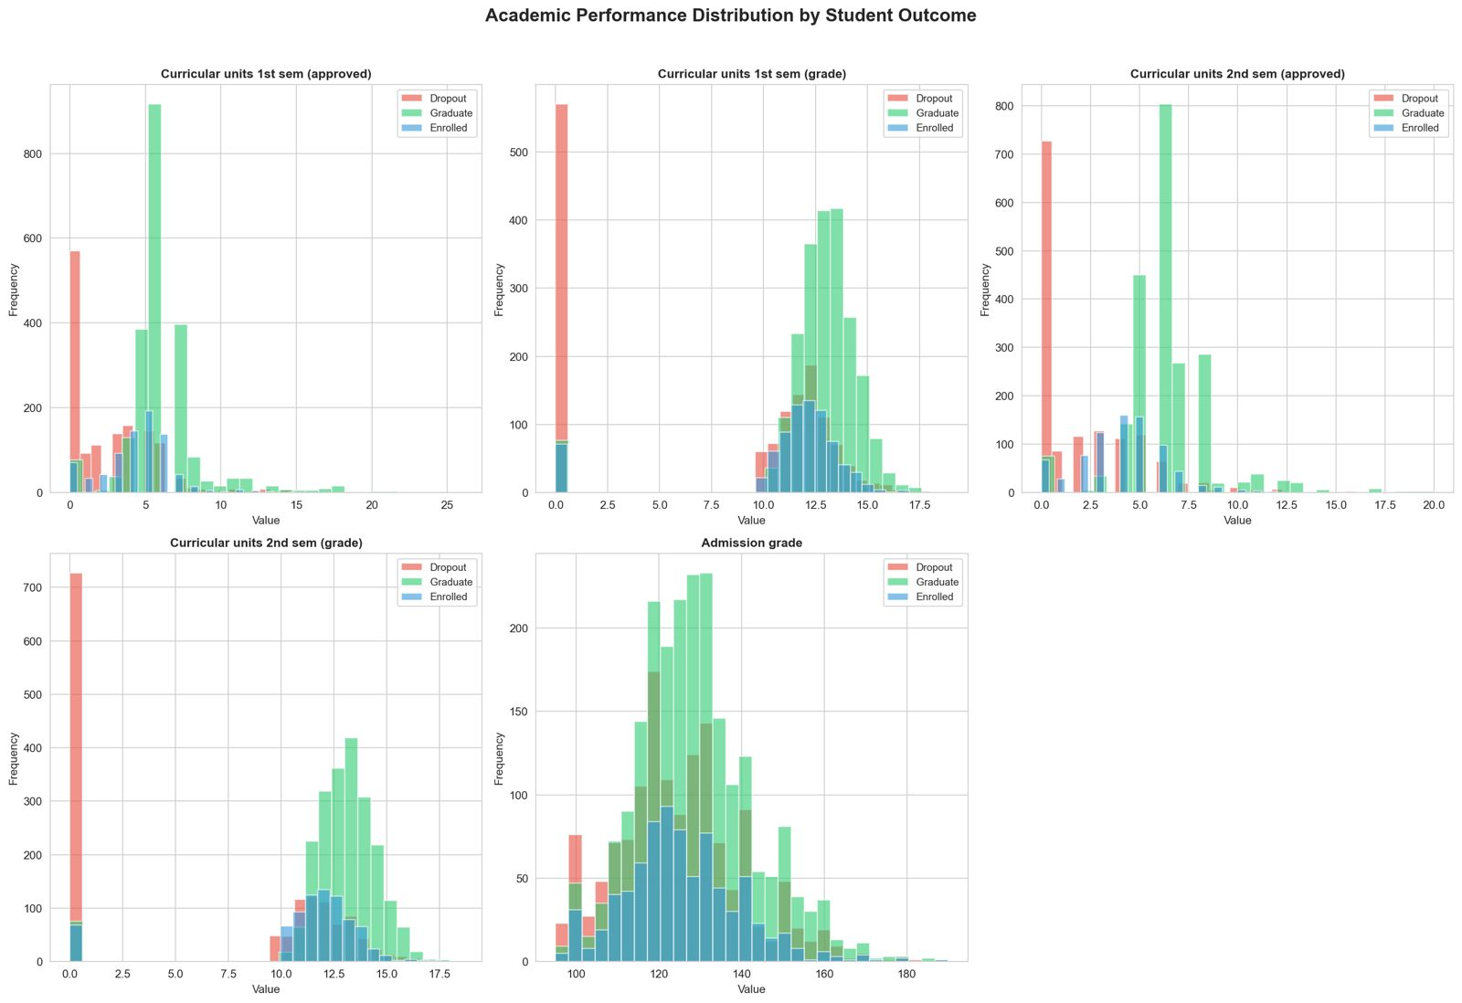
Academic performance features show the clearest separation between the three outcome classes of any feature group in the dataset. The mean number of curricular units approved in the 1st semester is 2.55 for dropout students, 4.32 for enrolled students, and 6.23 for graduates. The corresponding 1st semester grade averages are 7.26, 11.13, and 12.64 respectively. The pattern is consistent in the 2nd semester: dropout students average only 1.94 approved units and a grade of 5.90, against 6.18 units and 12.70 for graduates. Admission grade differences across groups are comparatively small (124.96 for dropouts vs. 128.79 for graduates), indicating that entry-level ability alone is a weak predictor of eventual outcome. These findings confirm that early in-programme academic performance is the dominant signal for dropout risk.

6.4) Demographic and Financial Analysis
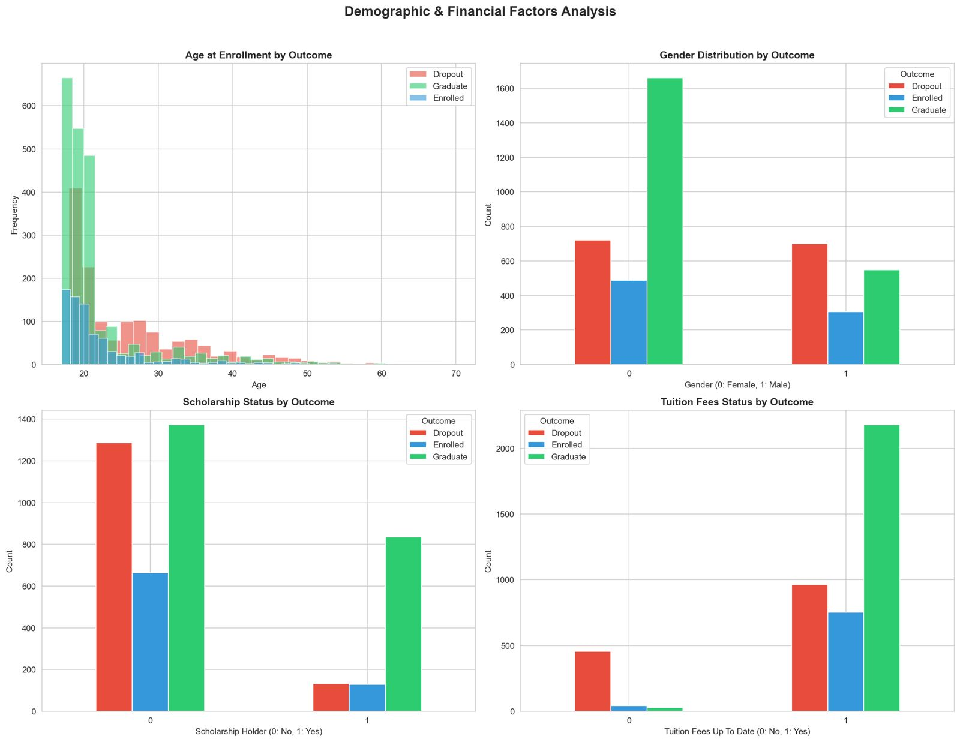
Age at enrollment differs meaningfully across outcome classes. Dropout students have a mean enrollment age of 26.1 years and a standard deviation of 8.7, compared to 21.8 years and 6.7 for graduates. This suggests that older, non-traditional students face substantially greater challenges in completing their degrees, likely reflecting competing responsibilities such as employment and family commitments.
Gender is a significant factor. Male students drop out at a rate of 45.1%, compared to 25.1% for female students. Conversely, female students graduate at a rate of 57.9%, nearly double the male graduation rate of 35.2%. This finding is consistent with broader trends in higher education literature, which have documented a persistent gender gap in completion rates favouring women.
Financial status is among the strongest predictors of dropout. Students holding a scholarship drop out at a rate of just 12.2%, compared to 38.7% for non-scholarship holders — a difference of over 26 percentage points. Students who are up to date on tuition fee payments show dramatically lower dropout rates than those who are in arrears. These findings collectively suggest that financial vulnerability is a major driver of non-completion, and that financial support interventions — such as grants and bursaries — may be among the most effective mechanisms for improving retention.

6.5) Financial and Macroeconomic Factors
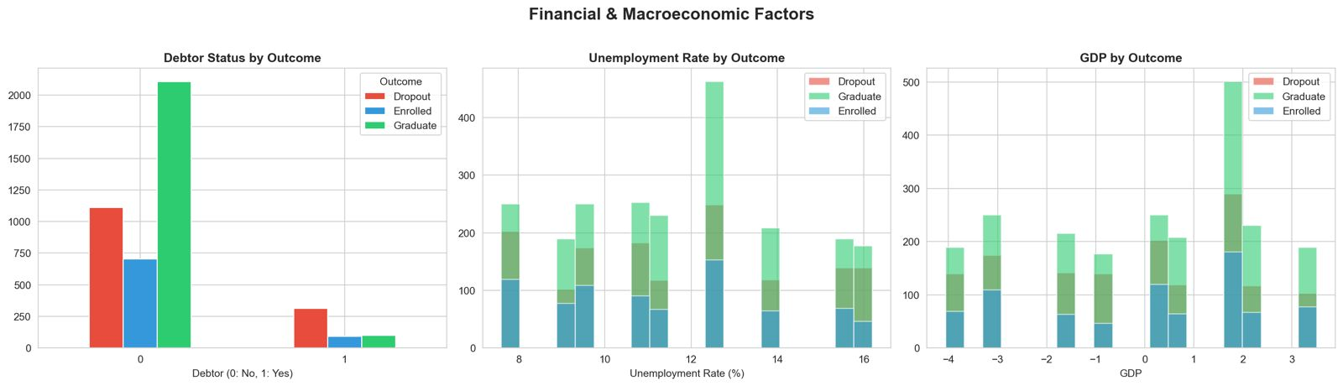
Students classified as debtors drop out at a rate of 62.0%, compared to 28.3% for non-debtors — the largest single-feature difference in dropout rate observed in the dataset. This finding underscores the critical role of financial distress in driving non-completion.
Macroeconomic indicators (GDP growth rate, unemployment rate) show only weak separation between outcome groups in their distributional plots. This is consistent with their low correlations with the dropout indicator, and supports the interpretation that individual-level financial and academic factors are substantially more predictive of dropout than the broader economic environment at the time of enrollment.

6.6) Box Plot Analysis of Key Features
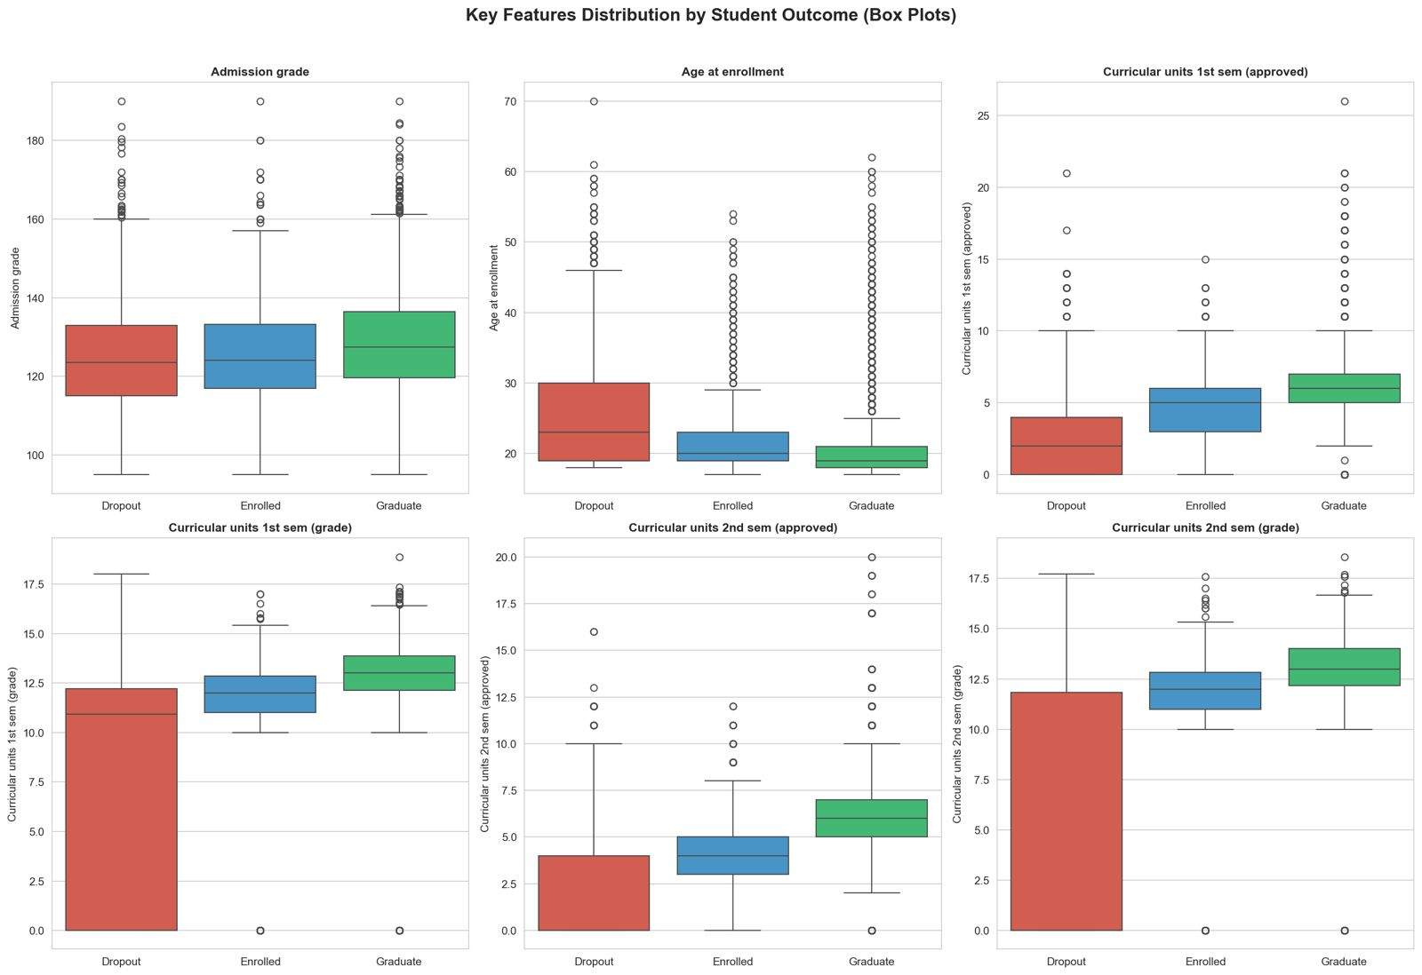
Box plot analysis confirms and extends the findings from the histogram analysis. The median number of approved units for dropout students in both semesters (approximately 0 in the 2nd semester) is dramatically lower than for graduates (approximately 6). The interquartile range for dropout students on academic performance metrics is also tighter and centred at low values, indicating that poor academic performance is a consistent — rather than occasional — characteristic of students who drop out. Age distributions show that dropout students have a higher median age and greater spread, while graduates are concentrated at younger ages.

6.7) Course-Level Dropout Analysis
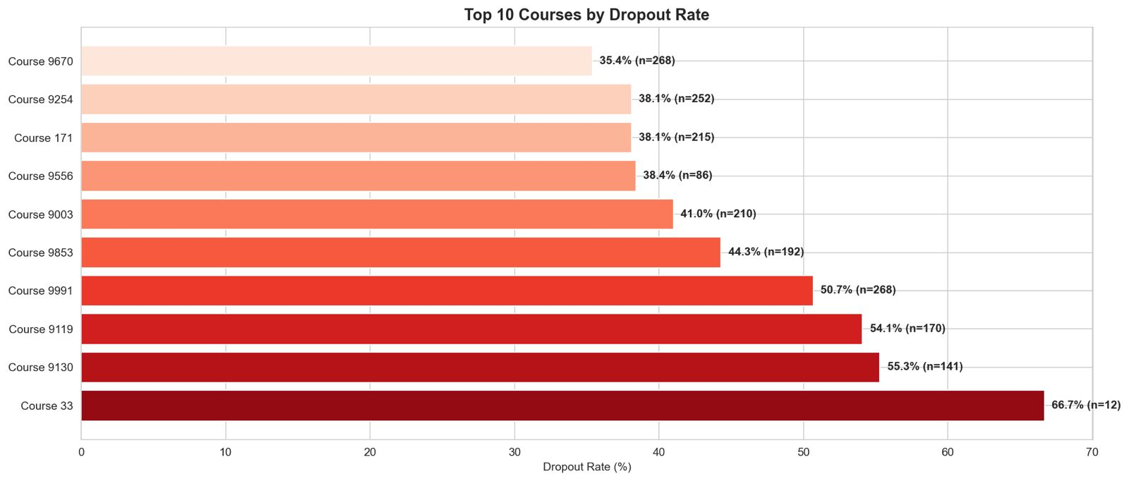
Dropout rates vary considerably across the academic programmes represented in the dataset. The highest dropout rates are observed for Course 33 (66.7%), Course 9130 (55.3%), and Course 9119 (54.1%). The lowest dropout rates are found in Course 9500 (15.4%) and Course 9238 (18.3%). These course-level differences may reflect differences in programme difficulty, student support resources, the socioeconomic backgrounds of students choosing particular fields of study, or labour market conditions specific to those career paths. This finding suggests that dropout risk models may benefit from incorporating course-specific effects.

6.8) Semester Performance Comparison
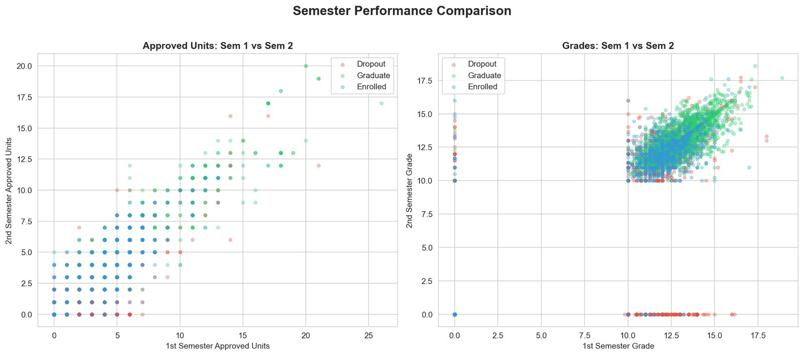
Scatter plots comparing 1st and 2nd semester performance reveal a striking pattern: dropout students are almost entirely concentrated in the bottom-left corner of both plots, indicating that students who perform poorly in the 1st semester almost universally also perform poorly in the 2nd semester — and ultimately leave the programme. Graduate students, by contrast, occupy the upper-right region of both plots, reflecting consistently high performance across both semesters. This confirms that dropout risk crystallises early in the academic journey and that strong early-semester performance is a reliable signal of eventual graduation.

6.9) Marital Status Analysis
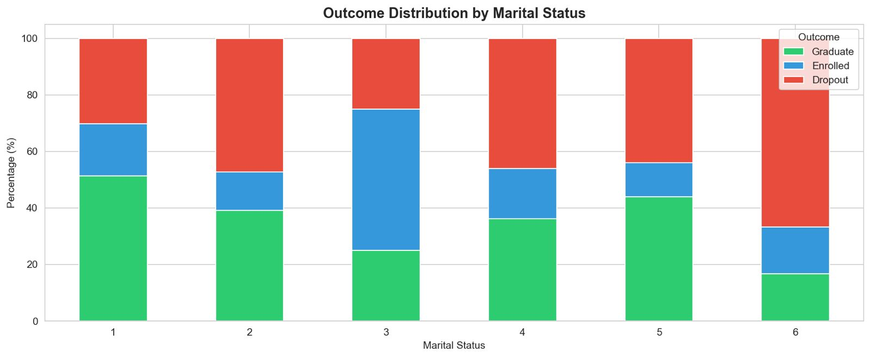
Marital status is encoded numerically in the dataset with the following key: 1 = Single, 2 = Married, 3 = Widower, 4 = Divorced, 5 = Facto Union (cohabiting without formal marriage), 6 = Legally Separated. The vast majority of students are single (category 1), reflecting the predominantly young, traditional-entry student population. Among non-single students, dropout rates are generally higher — particularly among divorced and legally separated students — consistent with the broader finding that students with additional life responsibilities face greater difficulty completing their degrees.

6.10) Feature Importance — Correlation with Dropout
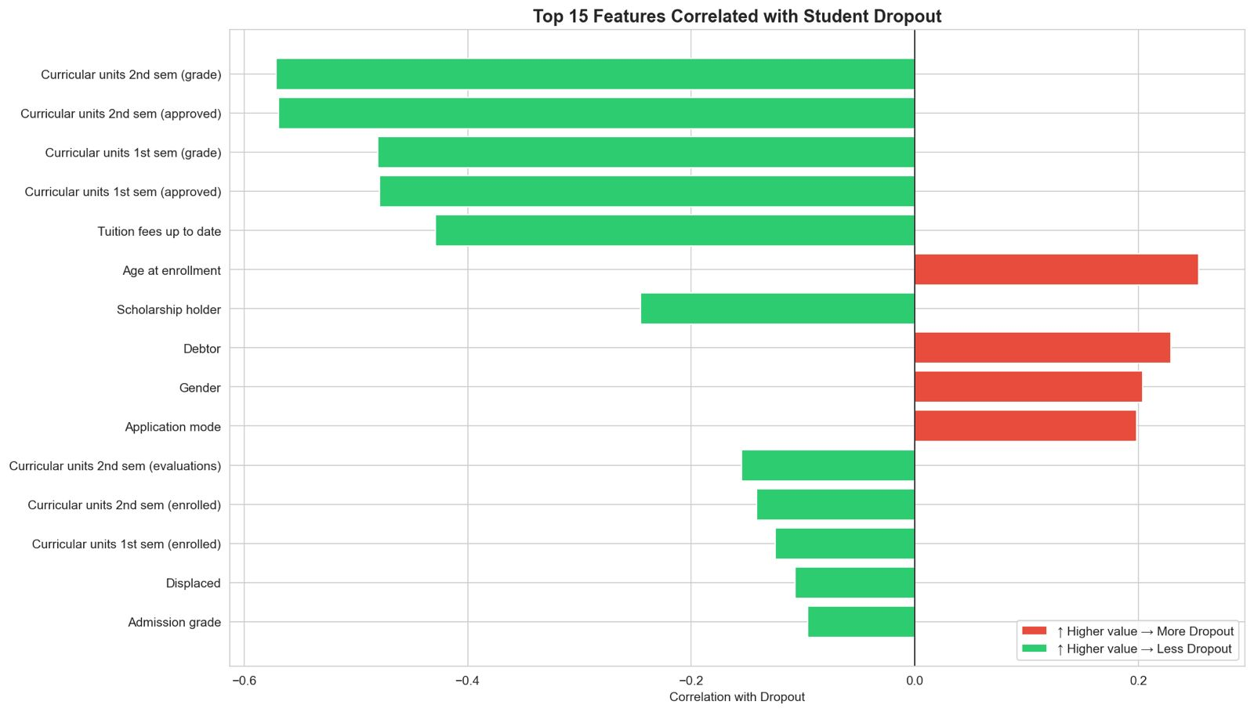
To provide a model-agnostic indication of feature relevance, Pearson correlations between each numerical feature and a binary dropout indicator were computed and ranked. The 15 features most strongly associated with dropout are as follows:

Rank | Feature | Correlation (r) | Interpretation
1 | 2nd Semester Grade | -0.572 | Higher grade → Less likely to drop out
2 | 2nd Semester Approved Units | -0.570 | More units passed → Less likely to drop out
3 | 1st Semester Grade | -0.481 | Higher grade → Less likely to drop out
4 | 1st Semester Approved Units | -0.479 | More units passed → Less likely to drop out
5 | Tuition Fees Up to Date | -0.429 | Fees paid → Less likely to drop out
6 | Age at Enrollment | +0.254 | Older students → More likely to drop out
7 | Scholarship Holder | -0.245 | Scholarship → Less likely to drop out
8 | Debtor Status | +0.229 | Debtor → More likely to drop out
9 | Gender | +0.204 | Male → More likely to drop out
10 | Application Mode | +0.199 | Certain application routes carry higher risk
11 | 2nd Semester Evaluations | -0.155 | More evaluations taken → Less likely to drop out
12 | 2nd Semester Enrolled Units | -0.142 | More units enrolled → Less likely to drop out
13 | 1st Semester Enrolled Units | -0.125 | More units enrolled → Less likely to drop out
14 | Displaced | -0.107 | Studying away from home region → Slightly less likely to drop out
15 | Admission Grade | -0.096 | Higher entry grade → Slightly less likely to drop out

Five key conclusions can be drawn from this ranking. First, academic performance in both semesters is overwhelmingly the most important predictor of dropout, with the top four features all measuring in-programme academic achievement. Second, financial factors — tuition fee status, scholarship holding, and debtor status — collectively form a second, distinct cluster of strong predictors. Third, demographic factors such as age, gender, and application mode contribute meaningful but weaker signal. Fourth, macroeconomic indicators such as GDP and unemployment rate do not appear among the top 15 predictors, confirming that individual circumstances dominate over broader economic conditions. Fifth, admission grade — often used as a primary indicator of student quality in institutional practice — ranks only 15th, suggesting that it is a poor proxy for dropout risk on its own.

7) Summary and Next Steps
The exploratory data analysis conducted in this phase of the project has yielded a clear and actionable picture of the factors driving student dropout at the dataset institution. The data is clean, complete, and rich in predictive signal. Academic performance in the first two semesters is the dominant predictor of dropout, followed by financial status and demographic factors. Macroeconomic conditions play a minimal role at the individual level
These findings directly inform the next phase of the project, in which machine learning models will be trained to operationalise these patterns into a reliable dropout prediction system. The strong predictive signal identified in the EDA gives confidence that classification models will achieve meaningful performance on this task. The class imbalance identified in the target variable will be addressed using SMOTE during preprocessing to ensure that the minority dropout class is well-represented in model training.
The ultimate deliverable of this project is an early warning system capable of flagging students at high risk of dropout at the end of their first semester — early enough for institutions to intervene effectively through targeted academic support, financial assistance, and personalised counselling programmes.

